Tru by Hilton Dallas Market Center
1949 N Stemmons Freeway, Dallas, TX 75207

Double Queen $151
King $151
Parking $20 per vehicle per night

To make reservations
https://www.hilton.com/en/attend-my-event/dfwmmru-tcf-3b7d6e4c-919e-4b1d-9c99-0b430f125193/

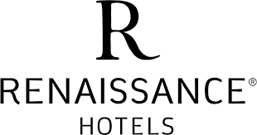

Renaissance Dallas Hotel
2222 North Stemmons Freeway, Dallas, TX 75207

Double/Queen $154 (gov per diem)
King $154 (gov per diem)
Group: FCCLA State Conference Overflow Room Block
Parking, Overnight Valet $32

To Make Reservations:
https://www.marriott.com/events/start.mi?id=1686172427091&key=GRP

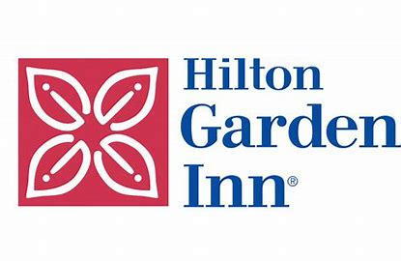
Hilton Garden Inn - Dallas Market Center
2325 North Stemmons Freeway, Dallas, TX 75207

King Deluxe with Sleeper Sofa $159
Standard King $159
Group: 2024 State Leadership Conference
Overnight Parking Included

To Make Reservations:
https://www.hilton.com/en/attend-my-event/dalmagi-csl1-e35c183e-c0b6-4886-832d-4c68da4fa438/

Virgin Hotels Dallas
1445 Turtle Creek Blvd, Dallas, TX 75207

Chamber Double Queens $165
Chamber Kings $165
Group: FCCLA Overflow Block
Overnight Parking – Valet Only $48

To Make Reservations:
Call Hotel Directly (469) 359-7700
https://virginhotels.com/dallas/reservations#/booking/step-2?arrive=04%2F11%2F2024&depart=04%2F14%2F2024&adults=1&group=7826557

